Investment Banking Analyst Salary 2027: What You Actually Take Home
Meta description: WSG founder Stephen Turban works the 2027 investment banking analyst salary from offer letter to bank account: base, bonus, every tax line, what's left.

A first-year analyst in New York earning $200,000 all-in keeps $130,282 of it. The other $69,718 goes to the IRS, Social Security, Medicare, New York State and New York City before it reaches a checking account [VERIFY: script-checked on the 2026 federal, New York State and New York City rules laid out in this article; refresh when the 2027 brackets publish]. Every investment banking analyst salary conversation I have with students starts from the gross number. Nobody has shown them the net.

I'm Stephen Turban, founder of WallStreetGuide. I went to Harvard and then McKinsey, not a bank, and what I do now is watch undergrads go through banking recruiting every cycle, including the week the offer letter arrives and the pay becomes real. That is usually when the questions change from "what's the bonus like" to "wait, why is my first paycheck $2,950."

This guide does the whole thing in order: the five pieces of the pay stack, base salary by bank tier, how bonuses get decided, the full tax math on one New York analyst line by line, the same gross in four cities, a monthly budget, what changes in years two and three, and what will actually move the numbers for the class that starts in summer 2027.

How much does a first-year investment banking analyst make?
At a bulge bracket bank in New York, a first-year analyst earns a $110,000 base salary, and the first-year bonuses paid in the Summer 2026 season ran from about $45,000 at the bottom of the class to about $100,000 at the top, so all-in pay landed between $155,000 and $210,000 [VERIFY: per-bank first-year reports on the Wall Street Oasis 2026 analyst bonus thread and Mergers & Inquisitions' February 2026 compensation report]. Elite boutiques pay a $120,000 base with a wider bonus range, so $170,000 to $230,000 is the normal spread there [VERIFY: Lazard and Rothschild first-year bases on the WSO 2026 thread; Evercore's $120,000 base as reported by Business Insider in August 2021]. The figures above are the latest confirmed numbers, from the 2026 analyst class and the Summer 2026 bonus season, and the class that starts in summer 2027 should expect the same scale unless banks raise bases again, which most haven't since 2022 [VERIFY: Mergers & Inquisitions, February 2026, "at most banks, these were last adjusted in 2022"].

How much of an investment banking salary goes to taxes?
About a third: on $200,000 of gross pay in New York City, a single analyst with no pre-tax deductions pays $36,734 of federal income tax, $14,339 of Social Security and Medicare, $11,328 to New York State and $7,317 to New York City. That's $69,718 in total, or 34.9 percent [VERIFY: 2026 federal brackets and standard deduction from IRS Rev. Proc. 2025-32; 2026 wage base from SSA; New York State and City rates from Form IT-2105-I (2026); script-checked]. A New York investment banking analyst salary loses about 35 cents of every dollar to taxes, and about 41 cents of each additional dollar through most of the 24 percent federal bracket. Move the same job to Houston and the tax bill drops to $51,073.

1. An investment banking analyst salary comes in five pieces, and only one of them arrives every two weeks
The offer letter quotes a base and hints at a bonus. The money actually shows up in five different ways, on five different schedules, and the schedule matters more than students expect because it decides when you can afford a deposit on an apartment.

Base salary is the only part of an investment banking analyst salary you can count on by the month. A $110,000 base paid over 26 biweekly paychecks is $4,231 of gross pay per check [VERIFY: $110,000 bulge bracket first-year base, WSO 2026 thread]. After withholding, in New York, the deposit is closer to $2,950, and under $2,800 once a 6 percent 401(k) contribution and the health premium come out, which is the number that surprises people (sections 4 and 5 show exactly why). Base salaries step up each year on a fixed scale and don't depend on how you're ranked.

A signing bonus is a one-time payment for accepting the offer, usually paid in your first month. At the big banks it has run about $10,000 to $15,000 for analysts, and Evercore put a $15,000 starting bonus on top of its $120,000 base when it raised pay in 2021 [VERIFY: signing bonus range from reported analyst offers; Evercore figure per Business Insider via eFinancialCareers, August 2021]. Summer Analysts who convert to a full-time offer usually get the same signing bonus as outside hires, which is one more reason converting the Summer Analyst seat is the whole game [VERIFY: signing bonus terms for converted interns at your bank].

A relocation payment covers the move. It's usually a lump sum of about $5,000 to $10,000, sometimes paid whether or not you actually moved [VERIFY: typical relocation range from reported offers]. One tax detail: since 2018, moving reimbursements count as taxable wages for everyone except active-duty military moving on orders and some intelligence community employees, and the 2025 tax law made that permanent, so a $7,500 relocation payment shows up on your W-2 like any other pay [VERIFY: IRS Publication 15-B (2026), "Moving Expense Reimbursements," P.L. 119-21].

Then the bonus, which comes in two shapes depending on your bank's calendar. At most bulge brackets the analyst bonus year runs July to June, so a July starter gets the first full bonus about 12 months in, the following summer. A few firms pay analysts on the calendar year instead. At those banks a July starter gets a prorated "stub" bonus the first December for the five or six months worked, then waits for the first full bonus the December after that. Centerview runs a December cycle with a large stub, William Blair's stub was reported at $22,500, and JPMorgan reportedly moved its analysts onto a winter cycle in 2026 and paid a $35,000 stub to bridge the gap [VERIFY: Centerview, William Blair and JPMorgan bonus timing per the WSO 2026 analyst bonus thread]. Ask which calendar your bank uses before you sign a lease that assumes a bonus in month six.

The year-end bonus is the piece that varies. Everything else is fixed by your bank and your class year; the bonus is set by how you were ranked and how the bank did. At the analyst level it is paid entirely in cash, no deferred stock, which is not true once you're a vice president [VERIFY: 100 percent cash analyst bonuses per Mergers & Inquisitions, February 2026].

Here is the stack for a bulge bracket first-year starting in 2027, on the 2026 scale.

Piece | When it lands | Typical size (bulge bracket, 2026 scale) | How payroll taxes it
Base salary | 26 biweekly paychecks | $110,000 | Regular wages, withheld by the tables
Signing bonus | First month | $10,000 to $15,000 | Supplemental wages, flat-rate withholding
Relocation | Around the move | $5,000 to $10,000 lump sum | Supplemental wages, taxable since 2018
Stub bonus | First December, only at calendar-year banks | Prorated for months worked | Supplemental wages
Year-end bonus | About 12 months in at most bulge brackets | $45,000 to $100,000 | Supplemental wages

[VERIFY: every figure in this table against the WSO 2026 analyst bonus thread and reported offer letters before publish]

All-in pay means base plus year-end bonus. Signing, relocation and stub payments are one-offs and don't belong in the number you compare across banks. When someone on a networking call says "I made $185,000 my first year," they mean $110,000 plus a $75,000 bonus, and they are not counting the $10,000 they got for showing up.

2. Base salary is set by your bank's tier, and it has barely moved since 2022
Banks don't negotiate analyst base salaries. Every first-year at a given bank gets the same number, and the number is set by where the bank sits in the market. The useful way to think about it is four tiers.

Tier | First-year base | Second-year base | Third-year base | First-year bonus range | First-year all-in range
Bulge bracket | $110,000 | $125,000 | $135,000 | $45,000 to $100,000 | $155,000 to $210,000
Elite boutique | $120,000 | $130,000 | $140,000 | $50,000 to $110,000 | $170,000 to $230,000
Middle market | $105,000 | $115,000 | $125,000 | $35,000 to $75,000 | $140,000 to $180,000
Regional boutique | $90,000 | $100,000 | $110,000 | $15,000 to $50,000 | $105,000 to $140,000

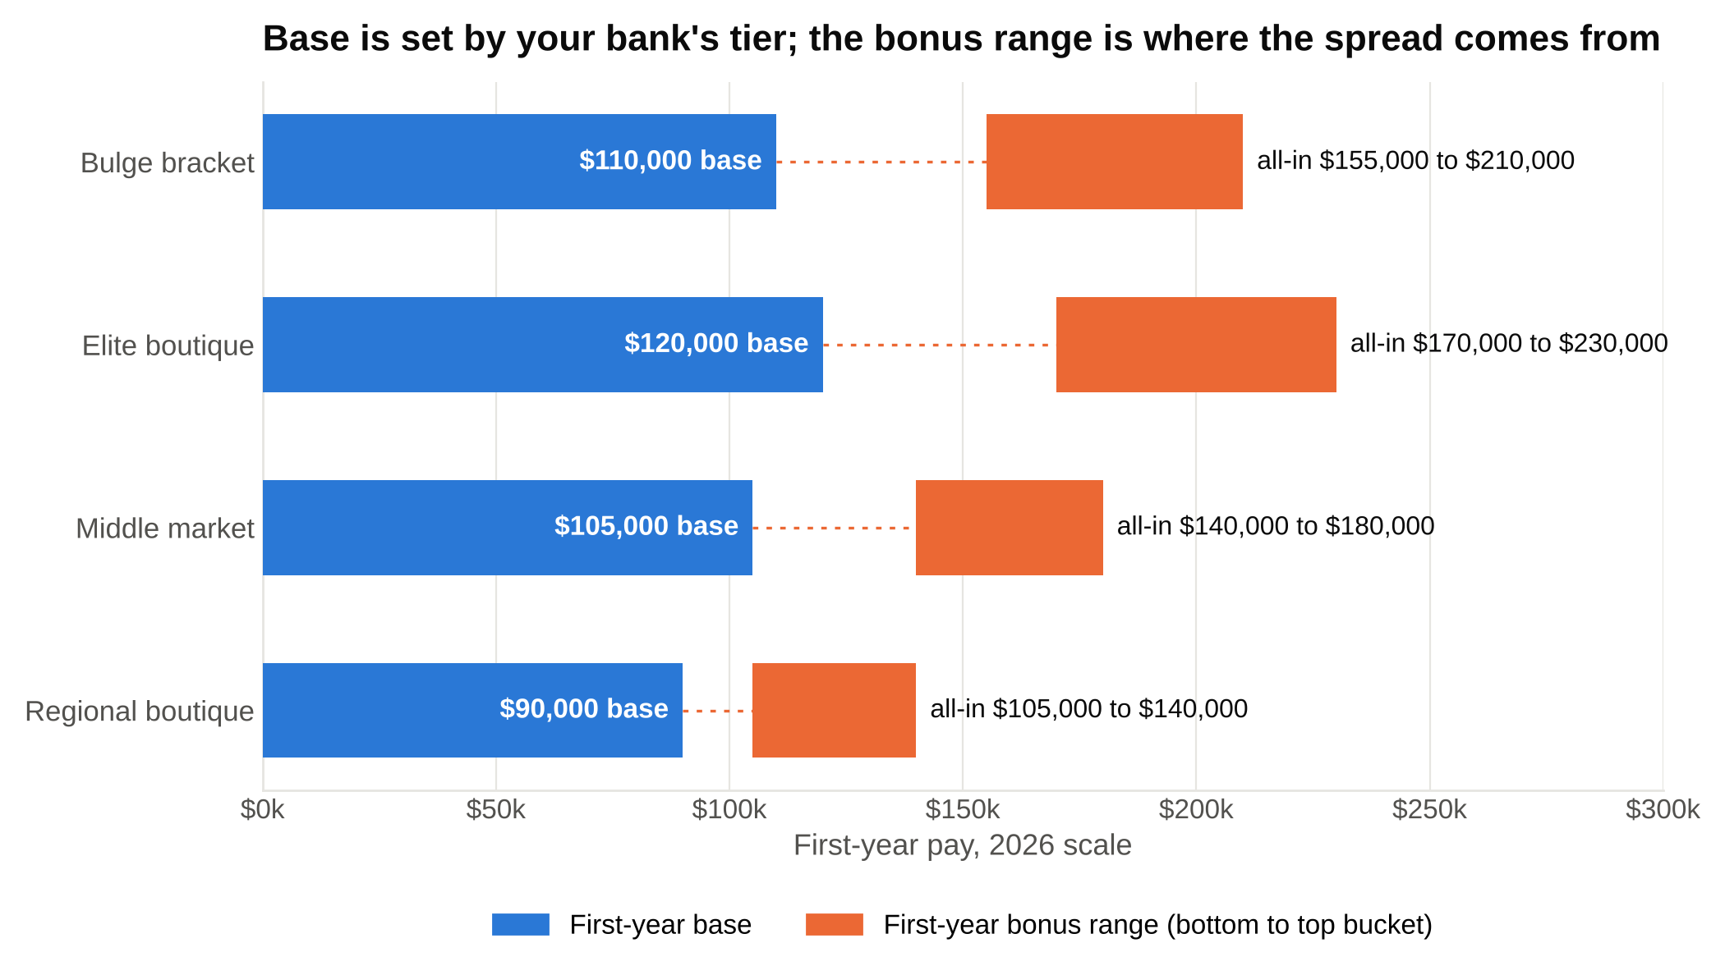
Base is fixed by tier, from $90,000 at a regional boutique to $120,000 at an elite boutique, and the orange bonus range is where two analysts on the same base end up $55,000 apart.

[VERIFY: bulge bracket scale from 2026 reports at Bank of America, Citi, Deutsche Bank, Morgan Stanley, UBS and Wells Fargo on the WSO 2026 analyst bonus thread ($110,000 / $125,000 / $135,000); elite boutique first-year base from Lazard and Rothschild reports on the same thread and Evercore's 2021 move to $120,000; middle market and regional ranges from Truist ($100,000), BMO and TD ($110,000) reports and WSO's February 2025 benchmarking thread; second and third-year elite boutique and middle market steps are estimates from the same sources]

The bulge bracket scale is $110,000, $125,000 and $135,000 for the three analyst years, and it is the same at Goldman Sachs, Morgan Stanley, Bank of America, Citi, Barclays, Deutsche Bank, UBS and Wells Fargo [VERIFY: Goldman and Barclays first-year bases; Goldman's $110,000 was last confirmed in the August 2026 WSG corrections log]. If a bank's analyst base is different from that scale, it is either an elite boutique paying above it or a middle market bank paying slightly below. Our breakdown of the top 10 investment banks covers which firms sit where.

Elite boutiques pay the most. Evercore, Lazard and Rothschild pay $120,000 to a first-year, Moelis, PJT and Perella Weinberg are reported at the same level, and Centerview is the firm everyone names as the top of the street: Wall Street Oasis's pay database shows an average total of about $225,600 across 42 Centerview analyst submissions, against about $180,100 across 240 Evercore submissions [VERIFY: Evercore, Lazard and Rothschild bases confirmed; Moelis, PJT and Perella Weinberg first-year bases; WSO company pay pages read October 2026, both averages mixing first, second and third-year analysts]. Centerview's first-year base is reported above the boutique scale, at $130,000, but only on prep sites and forums, so treat it as unconfirmed until you see an offer letter [VERIFY: Centerview first-year base, no primary source found]. Two things make the elite boutique number bigger than the base gap suggests: the bonuses run higher, and these firms pay them entirely in cash at every level, where the bulge brackets defer part of the bonus into stock once you're senior [VERIFY: M&I February 2026 on elite boutique cash bonuses].

Middle market banks like Jefferies, William Blair, Houlihan Lokey, Baird, Piper Sandler and Raymond James mostly sit at $100,000 to $110,000 for a first-year, with Jefferies and William Blair having matched the $110,000 bulge bracket number back in 2021 [VERIFY: Jefferies $110,000 and William Blair $110,000 per eFinancialCareers, August 2021; current bases at Houlihan Lokey, Baird, Piper Sandler and Raymond James]. The gap at this tier is in the bonus, not the base. Our guide to the top middle market investment banks goes through the firms.

Regional boutiques are the wide tier. A five-person M&A shop in Nashville might pay $75,000 and a $15,000 bonus; a strong regional firm might pay $95,000 and $40,000 [VERIFY: WSO February 2025 benchmarking thread put the boutique median at $95,000 base and $40,000 bonus]. Nobody publishes these, so ask the analyst you're networking with directly, and ask for the bonus range as well as the base.

Analyst base salaries jumped in 2021 and 2022 and have been flat since, so the base you'll be offered for 2027 is almost certainly the base the 2026 class got. The 2021 story is in section 10. The flat part is simpler: deal activity dropped in 2022 and 2023, hiring in competing industries went cold, and banks stopped feeling pressure to raise junior pay [VERIFY: Mergers & Inquisitions, February 2026, on bases last adjusted in 2022 and the 2022 to 2023 slowdown]. Mergers & Inquisitions' February 2026 report puts the analyst base range at $100,000 to $125,000 and all-in at $165,000 to $225,000 across the large banks, which matches the per-bank reports above [VERIFY: M&I February 2026 table, 25th to 75th percentile, New York front office].

3. The bonus is where two analysts with the same base end up $55,000 apart
Base is the same for everyone in your class. The bonus is not, and the mechanism that decides it is worth understanding before you start, because it's the one part of your pay you can influence.

Here is how a bank gets from "the year ended" to "your bonus is $75,000."

First, the bank sets a bonus pool. Banks budget total compensation as a share of revenue, a number called the comp ratio. Goldman Sachs paid $18.9 billion of compensation on $58.3 billion of revenue in 2025, a ratio of 32.4 percent [VERIFY: Goldman Sachs 2025 full-year results, 8-K exhibit filed January 2026]. Each division gets a slice of that budget, investment banking gets a slice of the division's, and the junior pool is carved out of that. A strong year for the bank makes every pool bigger; a weak year shrinks all of them before anyone looks at your performance.

Second, your group ranks you. Associates and vice presidents you worked with fill out reviews. Staffers add their view of how much work you took and how often you got pulled onto live deals. Group heads then sort the first-year class into buckets, usually three or four: top, upper-middle, middle, bottom. Some banks label them with numbers, which is why you'll see "1/1" and "3/3" in bonus threads [VERIFY: bucket labels as reported on the WSO 2026 thread]. The buckets are relative. If your whole class is strong, someone still lands in the bottom one.

Third, each bucket gets a number. In the Summer 2026 season, the reported first-year numbers at bulge brackets ran about $45,000 for the bottom bucket, $65,000 to $80,000 for the middle buckets, and $95,000 to $100,000 for the top, at Bank of America and Citi specifically [VERIFY: Bank of America first-year reports of $45,000 / $65,000 / $75,000 / $80,000 / $95,000 and Citi reports of $45,000 to $50,000 middle and $80,000 to $100,000 top, WSO 2026 thread]. Deutsche Bank's bottom bucket was reported at $20,000 and its top at $80,000, and Morgan Stanley's regional coverage middle bucket at $55,000, so the spread between banks inside the bulge bracket is real [VERIFY: Deutsche Bank and Morgan Stanley first-year reports, same thread]. At the elite boutiques, Lazard first-years reported $60,000 to $75,000 on a $120,000 base and Moelis first-years $75,000 to $90,000 [VERIFY: Lazard and Moelis reports, same thread].

The same $110,000 base produced first-year bonuses from $45,000 to $100,000 in 2026, which is a $55,000 gap in gross pay and a $33,677 gap in take-home. Here's what the buckets look like after New York taxes, using the tax engine from section 4.

Case | Base | Bonus | All-in | Total taxes | Take-home | Effective rate | Per month
Bulge bracket, bottom bucket | $110,000 | $45,000 | $155,000 | $52,007 | $102,993 | 33.6% | $8,583
Bulge bracket, middle bucket | $110,000 | $75,000 | $185,000 | $64,434 | $120,566 | 34.8% | $10,047
Bulge bracket, top bucket | $110,000 | $100,000 | $210,000 | $73,331 | $136,669 | 34.9% | $11,389
Elite boutique, middle bucket | $120,000 | $80,000 | $200,000 | $69,718 | $130,282 | 34.9% | $10,857
Elite boutique, top bucket | $120,000 | $110,000 | $230,000 | $82,185 | $147,815 | 35.7% | $12,318
Middle market, middle bucket | $105,000 | $55,000 | $160,000 | $54,109 | $105,891 | 33.8% | $8,824
Regional boutique | $90,000 | $30,000 | $120,000 | $37,146 | $82,854 | 31.0% | $6,904

[VERIFY: base and bonus inputs per section 2 and the WSO 2026 thread; taxes computed on 2026 rules for a single New York City resident with no pre-tax deductions, script-checked]

Three things decide which row you land in, and only one of them is you.

Your group's deal flow comes first. A first-year in a group that closed three deals is easier to rank at the top than one in a group that pitched all year, and group heads fight for pool share based on the fees their group brought in. Within a group, the analysts who were on the live deals get ranked above the ones who were on the pitches, partly because the deal teams are the people writing the reviews.

The bank's year comes second. In 2025, investment banking fees at Goldman rose 21 percent, and Mergers & Inquisitions' read on the season was that analyst and associate pay still rose only about 5 percent, because the extra revenue went to senior bankers and the banks didn't need to compete for juniors [VERIFY: Goldman 2025 investment banking fees of $9.34 billion, up 21 percent, per the 8-K exhibit; M&I February 2026 on the 5 percent junior increase]. When banks need to keep analysts, pools stretch. When nobody is leaving for tech or consulting, they don't.

Your ranking comes third, and it's the only lever you hold. The analysts who get the top bucket are the ones associates ask for by name. That comes from catching your own errors before the associate does, turning comments fast, and being reachable. None of that is complicated. All of it is tiring.

The bonus check will look much smaller than the bonus number, and most of that gap is withholding, not tax, which section 6 works through.

4. The full tax math on a $200,000 investment banking analyst salary in New York City, line by line
Take one analyst. Single, no kids, lives in Manhattan, earns a $120,000 base and an $80,000 bonus in the same calendar year. That's a top-bucket bulge bracket first-year or a middle-bucket elite boutique first-year, and it's the round number students have in their heads. I'll use the 2026 tax rules throughout because they're the latest the IRS and New York have published; the 2027 and 2028 brackets will be indexed up a bit for inflation, which helps you slightly [VERIFY: replace the 2026 parameters with 2027 figures once the IRS publishes them, expected October or November 2026, and with New York's 2027 schedule once posted].

Five separate taxes come out of that $200,000, and each one has its own rules. Here they are in the order payroll applies them.

Federal income tax is the biggest line, and it works in slices: you don't pay 24 percent on everything just because you're "in the 24 percent bracket." Start with gross pay of $200,000. Subtract the 2026 standard deduction for a single filer, $16,100, which is the amount of income the federal government doesn't tax at all [VERIFY: $16,100 single standard deduction, IRS Rev. Proc. 2025-32]. That leaves $183,900 of taxable income. Then each slice of that income is taxed at its own rate.

Taxable income slice | Rate | Dollars in slice | Tax
$0 to $12,400 | 10.0% | $12,400 | $1,240
$12,400 to $50,400 | 12.0% | $38,000 | $4,560
$50,400 to $105,700 | 22.0% | $55,300 | $12,166
$105,700 to $183,900 | 24.0% | $78,200 | $18,768
Total federal income tax |  | $183,900 | $36,734

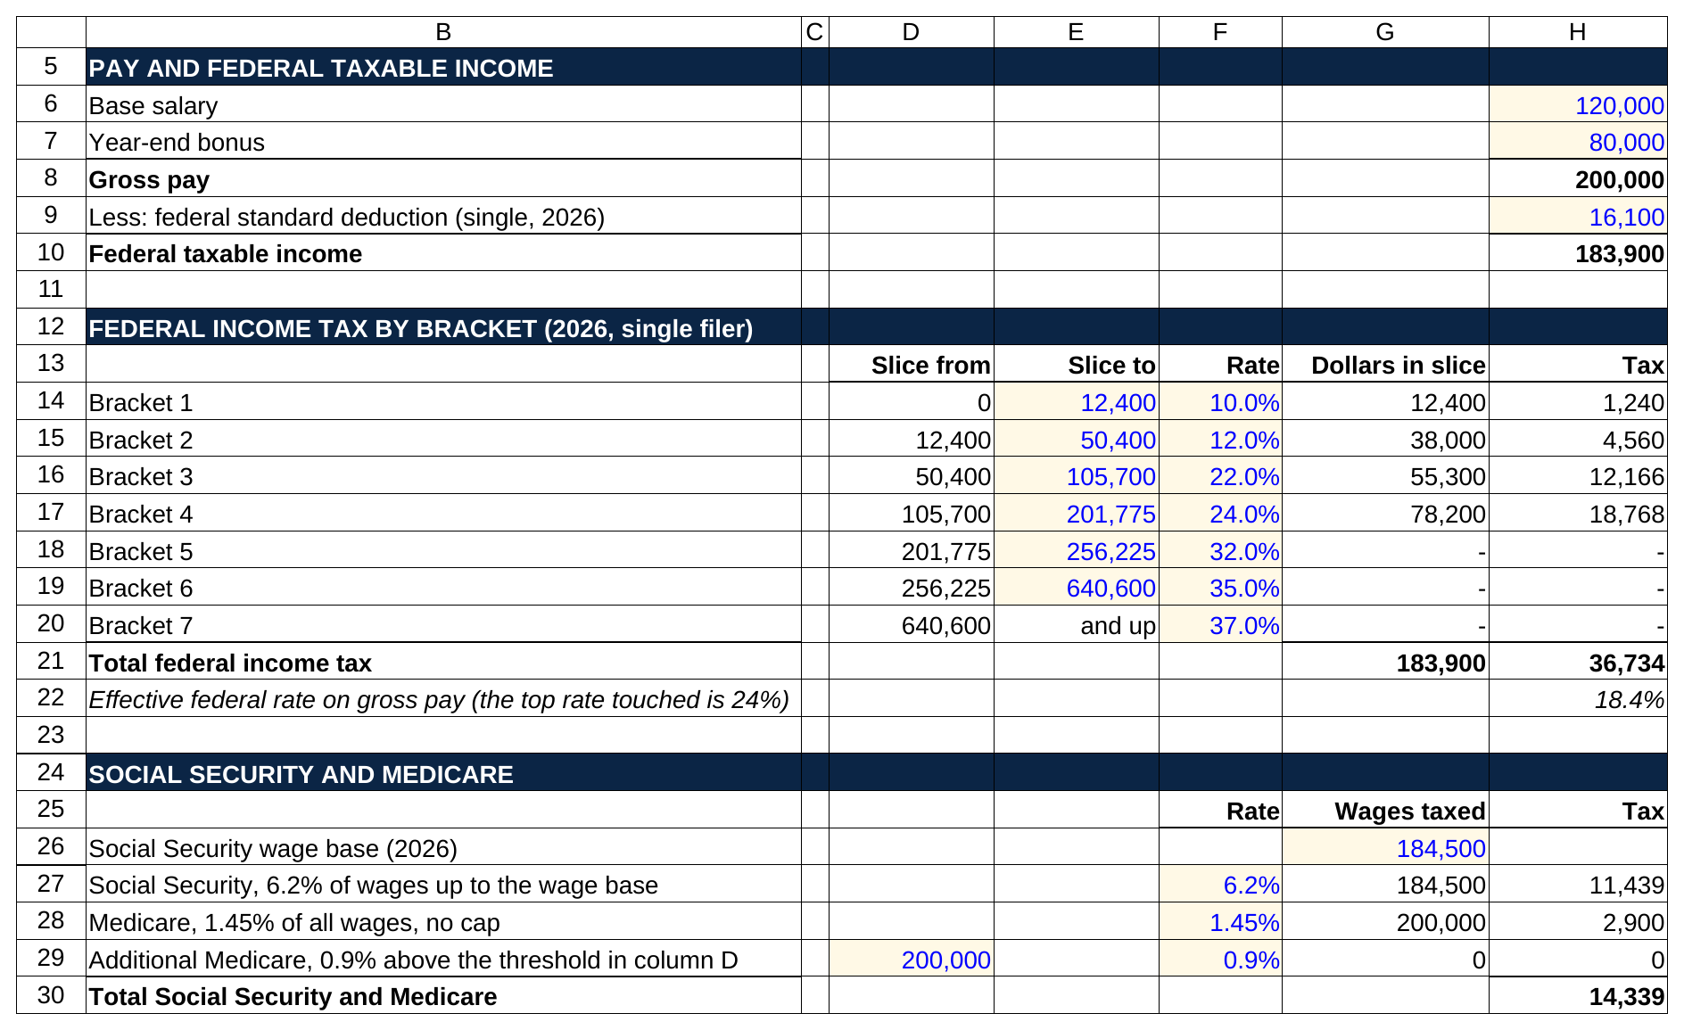
Only the first four brackets touch $183,900 of taxable income, so the three rows above them show a dash, and the slices add to $36,734 before Social Security and Medicare take another $14,339.

[VERIFY: 2026 single-filer brackets of 10, 12, 22 and 24 percent with thresholds at $12,400, $50,400, $105,700 and $201,775, IRS Rev. Proc. 2025-32]

The first $12,400 of taxable income is taxed at 10 percent, the next $38,000 at 12, the next $55,300 at 22, and only the last $78,200 at 24. Add the four slices and the federal bill is $36,734, which is 18.4 percent of gross pay even though the top rate touched was 24. The 24 percent is the marginal rate, meaning the tax on the next dollar. The 18.4 percent is the effective rate, meaning the average on all the dollars. Interviewers won't ask you this, but you'll want it the first time you budget a bonus.

Social Security is next, at 6.2 percent of wages up to a cap. The cap, which the Social Security Administration calls the wage base, is $184,500 for 2026, so this analyst pays 6.2 percent of $184,500, or $11,439, and nothing on the last $15,500 [VERIFY: 2026 wage base of $184,500 per SSA]. The wage base is the reason the Social Security line in your paychecks disappears late in the year once you've crossed it, and then reappears in January. For a sense of how far the cap has traveled: when the tax started in 1937, it was 1 percent on the first $3,000 of wages, a maximum of $30 a year; the 2026 maximum is $11,439 [VERIFY: 1937 wage base of $3,000 and 1 percent employee rate per SSA's contribution and benefit base and tax rate history pages].

Medicare is 1.45 percent of all wages with no cap, so $2,900 on $200,000. There's also an additional 0.9 percent Medicare tax on wages above $200,000, which this analyst just misses; the second-year in section 9 doesn't [VERIFY: 1.45 percent Medicare rate and 0.9 percent additional tax above $200,000, IRS Publication 15 (2026)].

New York State is where it gets interesting. New York's own standard deduction for a single filer is $8,000, so New York taxable income is $192,000 [VERIFY: $8,000 New York standard deduction, Form IT-2105-I (2026)]. The published rate schedule starts at 3.9 percent and climbs through 4.4, 5.15, 5.4 and 5.9 percent to reach 6.85 percent above $215,400 [VERIFY: 2026 New York State single-filer schedule, Form IT-2105-I (2026), page 10]. Run $192,000 through that schedule and you'd get $10,760. New York doesn't let a banker use the schedule: once your New York adjusted gross income passes $157,650, the state phases out the lower brackets entirely and taxes your whole taxable income at a flat 5.9 percent. (New York adjusted gross income is your federal adjusted gross income with a few state adjustments; for an analyst it's total wages minus any 401(k) deferral and pre-tax health premium.) The phase-out starts at $107,650 of income and finishes $50,000 later, and it's buried in a tax computation worksheet most people have never seen [VERIFY: Form IT-2105-I (2026), tax computation worksheet 7 for single filers]. For our analyst that means 5.9 percent of $192,000, or $11,328. The schedule would have saved $568. Higher up, above $215,400 of income, a second worksheet phases everything toward 6.85 percent, which is why the effective rate in the three-year table later keeps creeping up.

New York City then takes its own cut. If you live in any of the five boroughs, the city taxes the same $192,000 of taxable income on a four-step schedule.

NYC taxable income slice | Rate | Dollars in slice | Tax
$0 to $12,000 | 3.078% | $12,000 | $369
$12,000 to $25,000 | 3.762% | $13,000 | $489
$25,000 to $50,000 | 3.819% | $25,000 | $955
$50,000 to $192,000 | 3.876% | $142,000 | $5,504
Total NYC tax |  | $192,000 | $7,317

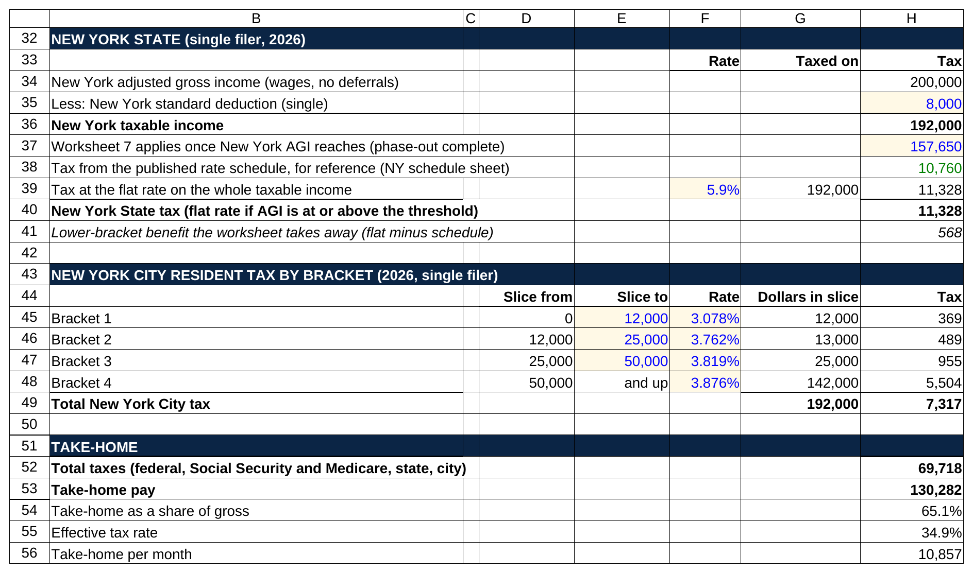
The schedule would charge $10,760, but worksheet 7 taxes all $192,000 at a flat 5.9 percent for $11,328, the city adds $7,317 on its four slices, and the sheet lands on the same $130,282.

[VERIFY: 2026 New York City resident single-filer schedule, Form IT-2105-I (2026)]

Put it all together.

Line | Amount
Base salary | $120,000
Year-end bonus | $80,000
Gross pay | $200,000
Minus federal standard deduction | $16,100
Federal taxable income | $183,900
Federal income tax (from the bracket table) | $36,734
Social Security, 6.2% of the first $184,500 | $11,439
Medicare, 1.45% of all wages | $2,900
Additional Medicare, 0.9% above $200,000 | $0
New York taxable income (gross minus the $8,000 New York standard deduction) | $192,000
New York State tax (flat 5.9% under worksheet 7) | $11,328
New York City resident tax | $7,317
Total taxes | $69,718
Take-home pay | $130,282
Take-home as a share of gross | 65.1%
Effective tax rate | 34.9%
Take-home per month | $10,857

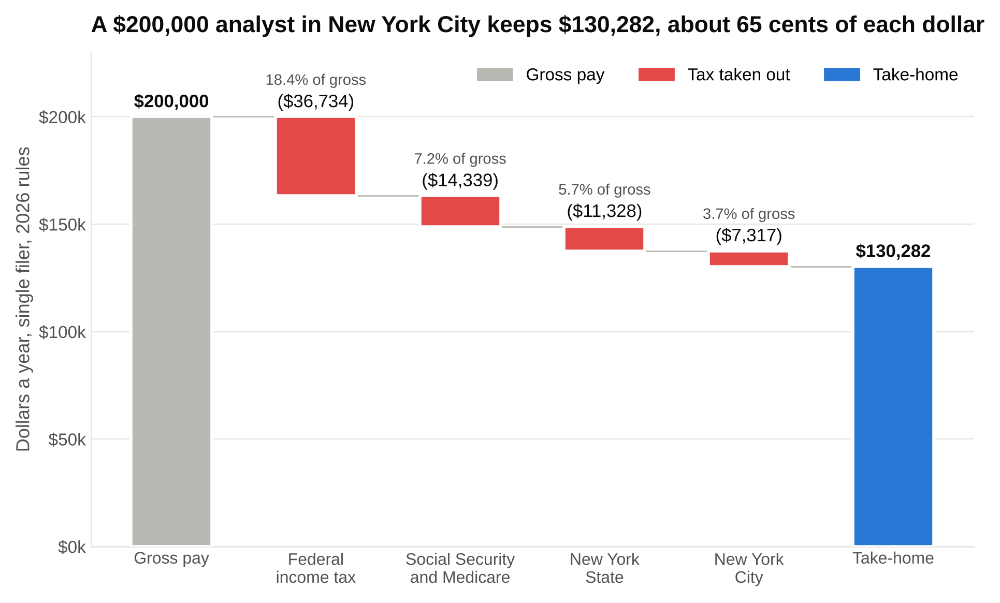
Federal income tax is the biggest bar at 18.4 percent of gross, and the two New York bars together are the $18,645 that a Houston analyst never pays.

[VERIFY: every input above per the sources in this section; arithmetic script-checked in `numbers_investment-banking-analyst-salary-2027.py`]

A $200,000 investment banking analyst salary in New York City becomes $130,282 of take-home, about $10,857 a month: 18.4 percent of gross goes to federal income tax, 7.2 percent to Social Security and Medicare, 5.7 percent to the state and 3.7 percent to the city. The split is worth remembering because the federal part is the same everywhere in the country. The New York part is what you're choosing when you choose the city.

One more number before moving on, because it changes how you think about the bonus. At $200,000 in New York, the next dollar you earn is taxed at 24 percent federal, 5.9 percent state and 3.876 percent city, plus 1.45 percent Medicare and the 0.9 percent additional Medicare that kicks in right at $200,000. That's 36.1 percent, and it's 41.4 percent on dollars earned between $157,650 and the $184,500 wage base, when Social Security's 6.2 percent is still being taken. So of a $10,000 bigger bonus, you keep about $6,400.

A note on the calendar. A July 2027 start means your first calendar year holds six months of base and no full bonus. On a $120,000 base that's $60,000 of gross pay, taxed at only 23.6 percent ($14,144) because the deductions and the low brackets cover a much bigger share of a half year of income. Your first W-2 will look gentle. The second calendar year, with twelve months of base and the first full bonus, is the one the table above describes.

5. A 6 percent 401(k) contribution costs you about $660 per $1,000, not $1,000
Almost every bank lets you put part of each paycheck into a 401(k) before tax, and many match some of it. Students skip it in year one because the deposit already feels small. Here is what the deduction actually does to the same analyst.

A 401(k) deferral comes out of your pay before federal, state and city income tax are calculated, but not before Social Security and Medicare, while a health premium paid through the bank's plan comes out before all five. That difference is the whole table below. Assume 6 percent of gross, or $12,000, goes into the 401(k), well under the 2026 limit of $24,500, and the analyst pays $1,500 a year for the bank's single health plan, which is close to the $1,440 average worker contribution for single coverage in KFF's 2025 employer survey [VERIFY: $24,500 limit per IRS Notice 2025-67; $1,440 per KFF 2025 Employer Health Benefits Survey; your bank's premium will differ].

Line | No deductions | 6% 401(k) + health
Gross pay | $200,000 | $200,000
401(k) deferral (6% of gross) | $0 | $12,000
Health premium (pre-tax) | $0 | $1,500
Wages subject to income tax | $200,000 | $186,500
Wages subject to Social Security and Medicare | $200,000 | $198,500
Federal income tax | $36,734 | $33,494
Social Security | $11,439 | $11,439
Medicare (including additional) | $2,900 | $2,878
New York State tax | $11,328 | $10,532
New York City tax | $7,317 | $6,794
Total taxes | $69,718 | $65,137
Cash in your checking account | $130,282 | $121,363
Cash plus 401(k) balance | $130,282 | $133,363
Take-home per month | $10,857 | $10,114

[VERIFY: same tax parameters as section 4; script-checked]

Read the two cash lines together. Putting $12,000 into the 401(k) and $1,500 into health insurance reduced the checking account by $8,918, not $13,500, because the deductions cut the tax bill by $4,582. Every $1,000 you defer into a 401(k) at this income costs about $662 of take-home, because the other $338 would have gone to federal, state and city income tax. If your bank matches, the math gets better still, and a match you don't claim is pay you're leaving on the table [VERIFY: 401(k) match terms at your bank].

Social Security didn't move in the table because this analyst is above the wage base either way. For a first-year at $155,000, the health premium would also shave a little Social Security, and the 401(k) still wouldn't, because Congress made retirement deferrals exempt from income tax but not from payroll tax.

This is also the year to open the 401(k) regardless of the match, for a reason that has nothing to do with tax. The first-year analyst who defers 6 percent from the first paycheck never sees that money in checking and never builds a lifestyle around it. The one who plans to "start next year" is choosing between the 401(k) and an apartment upgrade by then.

6. Your bonus check will look small, and most of that is withholding, not tax
A student I worked with through WSG, call him R, signed with an elite boutique and texted me a screenshot of his first full bonus pay stub asking whether payroll had made a mistake. $80,000 on the top line. $43,520 deposited. No mistake. That's what supplemental withholding looks like in New York, and it's worth knowing before your own stub arrives.

Payroll treats a bonus as "supplemental wages" and withholds at flat rates instead of using the tables it uses for your base. The federal flat rate is 22 percent on supplemental wages up to $1 million in a year [VERIFY: IRS Publication 15 (2026), section 7]. New York State's supplemental rate is 11.70 percent and New York City's is 4.25 percent, rates built for the highest earners and far above the 5.9 and 3.876 percent a first-year actually owes [VERIFY: NYS-50-T-NYS and NYS-50-T-NYC (1/26), supplemental wage withholding rates]. Social Security and Medicare come out at their normal rates. Stack the five flat rates and payroll withholds 45.6 percent of a New York bonus check, even though the bonus's real tax cost for a first-year is about 41 percent.

The real tax the bonus adds to your year is lower. The way to see it is to compute the whole year's tax with and without the bonus and take the difference.

Item | Withheld from the check | Actual tax the bonus adds
Federal income tax | 22.0% = $17,600 | $19,164
Social Security | 6.2% = $4,960 | $3,999
Medicare | 1.45% = $1,160 | $1,160
New York State | 11.70% = $9,360 | $5,148
New York City | 4.25% = $3,400 | $3,101
Total | 45.6% = $36,480 | 40.7% = $32,572
Bonus you keep | $43,520 | $47,428

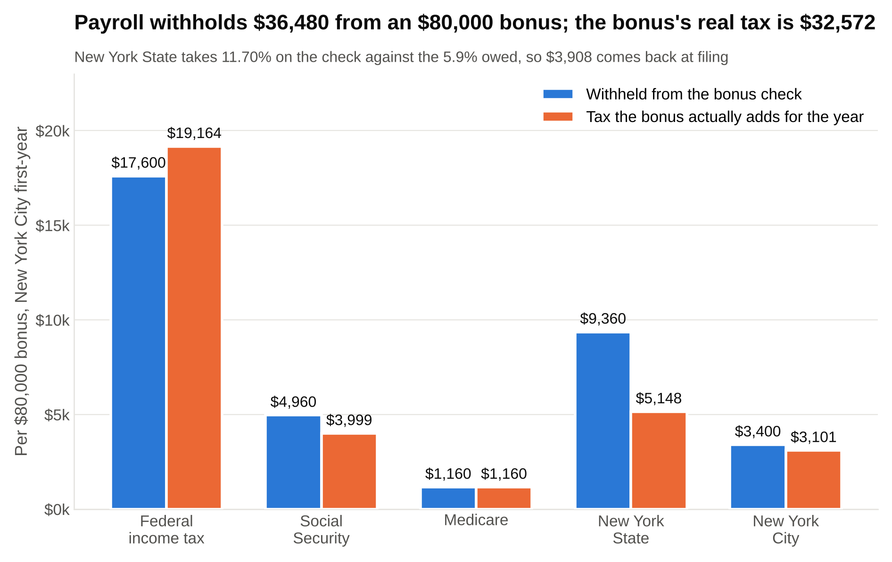
Federal is under-withheld because 22 percent is less than the 24 percent bracket, New York State is over-withheld by almost half, and the net $3,908 comes back as a refund.

[VERIFY: withholding rates as above; the "actual" column is the difference between the full-year tax with and without the $80,000 bonus on 2026 rules, script-checked]

Two things stand out. The federal line is under-withheld, because 22 percent is less than the 24 percent bracket most of the bonus falls into. New York over-withholds by almost half, because 11.70 percent is nearly double the 5.9 percent you owe. Net, payroll took $3,908 more than the bonus actually cost, and you get that back as a refund when you file, or sooner by adjusting your W-4, the form that tells payroll how much to withhold from your regular paychecks. The Social Security line is lower in the actual column for the reason in section 4: base plus bonus crosses the $184,500 wage base, so the last $15,500 of the year's wages owes no Social Security at all.

Withholding is an estimate payroll makes on each check; your tax is calculated once, on the whole year, when you file. A bonus check that looks 45 percent lighter is not a 45 percent tax. R got about $3,900 back the following April [VERIFY: composite; swap in a real WSG student story if one exists].

The practical move: don't plan around the bonus's gross number, and don't plan around the stub's net number either. Plan around the actual column. For an $80,000 bonus in New York, that's about $47,400 you'll actually keep, part on bonus day and part the next spring.

7. The same $200,000 is worth $18,645 more in Houston than in New York
Every bank with a New York office also has analysts in Charlotte, Houston, San Francisco, Chicago and Los Angeles, and most of them pay the same base in every US city. The tax bill is not the same. Here's the identical analyst, $120,000 base and $80,000 bonus, single, no deductions, in four cities.

Line | New York | Charlotte | Houston | San Francisco
Federal income tax | $36,734 | $36,734 | $36,734 | $36,734
Social Security + Medicare | $14,339 | $14,339 | $14,339 | $14,339
State income tax | $11,328 | $7,471 | $0 | $14,211
City income tax | $7,317 | $0 | $0 | $0
State disability insurance | $0 | $0 | $0 | $2,600
Total taxes | $69,718 | $58,544 | $51,073 | $67,884
Take-home pay | $130,282 | $141,456 | $148,927 | $132,116
Take-home per month | $10,857 | $11,788 | $12,411 | $11,010
Effective tax rate | 34.9% | 29.3% | 25.5% | 33.9%
Gap versus New York (a year) | $0 | $11,174 | $18,645 | $1,834

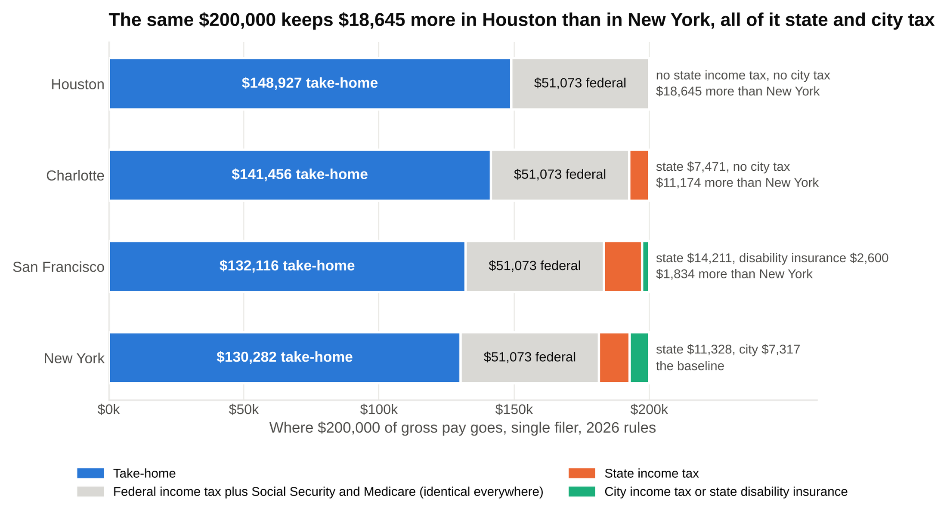
The gray federal block is identical in all four cities, so every dollar of difference sits in the orange and green state and city segments on the right.

[VERIFY: North Carolina 3.99 percent flat rate for tax years after 2025 and $12,750 single standard deduction per ncdor.gov (2026 deduction not yet posted); Texas has no individual income tax; California 2026 indexed schedule, $5,900 standard deduction and $158 exemption credit per FTB Tax News 2026 indexing; California SDI 1.3 percent with no wage ceiling per EDD; script-checked]

Federal income tax and payroll taxes are identical in every city, so the $18,645 gap between Houston and New York is entirely state and city income tax. Everything that differs is in the bottom half of the table.

Charlotte is simple. North Carolina charges one flat rate on income after a $12,750 standard deduction, and the rate is 3.99 percent for 2026, down from 4.25 percent in 2025, with further cuts scheduled if revenue targets are hit [VERIFY: ncdor.gov tax rate schedules]. No city tax. The analyst keeps $11,174 more than in New York.

Houston is simpler. Texas has no personal income tax, so the only taxes are federal [VERIFY: Texas levies no individual income tax]. The analyst keeps $148,927, which is $18,645 more than in Manhattan, and rent is roughly half, so the real gap is bigger than the tax gap. The trade is that Houston banking is mostly energy coverage, which is a career choice as much as a cost-of-living one.

San Francisco surprises people. California's brackets climb quickly and this analyst's top dollars are taxed at 9.3 percent, but the state's standard deduction is small ($5,900), the personal exemption is a $158 credit, and California adds a 1.3 percent state disability insurance deduction on every dollar of wages with no cap [VERIFY: FTB and EDD figures as above]. Add it up and San Francisco's bill is $67,884, only $1,834 less than New York's. The difference between the two most expensive cities is almost entirely that New York has a city income tax and San Francisco doesn't.

New York City is the reason the New York column is highest: of the ten largest US cities, only New York and Philadelphia tax their residents' wages, and NYC's 3.876 percent top rate costs this analyst $7,317 a year [VERIFY: Tax Foundation "Local Income Taxes: A Primer" (2023, updated 2024) lists about 5,000 local taxing jurisdictions in 16 states, mostly small municipalities and school districts in Pennsylvania, Ohio, Maryland and Indiana, with New York City, Philadelphia, Detroit, Baltimore and Columbus the large cities among them]. Chicago, Los Angeles, Houston, Dallas, Boston, Charlotte and San Francisco charge their residents nothing on wages.

That's also why a lot of first-years end up in Hoboken or Jersey City. Live in New Jersey and work in Manhattan and you pay New Jersey tax instead, with a credit for the New York State tax you owe as a nonresident, and the city's $7,317, about $610 a month, never shows up [VERIFY: New Jersey resident credit for taxes paid to New York; the net saving depends on the New Jersey schedule and is close to but not exactly the NYC tax]. Whether the PATH train is worth $610 a month is a personal question. It is at least a question worth asking with the number in front of you.

8. A first-year in New York can save $4,000 to $6,000 a month if rent stays under $2,500
Take-home in section 5, with the 401(k) and health premium coming out, is $10,114 a month. Here's what that buys in Manhattan in late 2026.

Rent decides everything. Studio asking rents in the neighborhoods analysts actually live in ran about $3,400 to $4,200 in October 2026: roughly $3,450 on the Upper East Side, $3,500 in the East Village, $3,770 in Hell's Kitchen, $3,900 in Murray Hill and $4,160 in the Financial District, with the Manhattan median asking rent across all apartment sizes at $4,927 in StreetEasy's May 2026 report [VERIFY: neighborhood studio medians per RentHop, October 2026 (Zumper shows $3,775 for an Upper East Side studio and $4,013 in the Financial District the same month); Manhattan median per StreetEasy, May 2026]. A bedroom in a shared two or three-bedroom in the same neighborhoods runs about $2,200 to $3,000 [VERIFY: share-of-apartment estimate; check against current StreetEasy two and three-bedroom listings in Murray Hill, Kips Bay, the Upper East Side and the Financial District].

Landlords qualify you on your base salary, not your bonus, so the 40x rule decides your apartment before the first bonus ever hits. The rule: your annual income has to be at least 40 times the monthly rent, and a guarantor usually needs 80 times [VERIFY: 40x and 80x conventions per NYC rental guides; some buildings use 45x or accept an offer letter]. A $2,500 room needs $100,000 of income and a $3,800 studio needs $152,000. On a $110,000 base alone, the studio fails the test, which is why first-years get asked for an offer letter showing the bonus target, a guarantor, or several months of rent up front. The bonus doesn't count until it's on a pay stub.

One piece of good news for the 2027 class: since June 2025, New York's FARE Act has required the party who hires a broker to pay the broker, which for most listings means the landlord. StreetEasy estimated the average fee a renter would otherwise have paid at lease signing at $5,862 in May 2026, against about $46 a month of higher asking rent on the affected listings [VERIFY: StreetEasy, June 11, 2026 post on the FARE Act's first year]. For a first-year with a $10,000 signing bonus, not writing a $5,000 check to a broker is the difference between furnishing the apartment and not.

Transit is cheap. OMNY caps subway and bus fares at $35 a week, so riding every day costs about $152 a month, and most desks cover a car home after a late hour [VERIFY: $3 fare and $35 weekly cap per mta.info, October 2026; car and dinner policies by bank]. Food is cheaper than it looks on paper for the same reason: the desk pays for dinner on the nights you're there past the cutoff, which as a first-year is most nights.

Line | Shared, careful | Shared, typical | Studio, typical
Take-home per month | $10,114 | $10,114 | $10,114
Rent | $2,500 | $2,500 | $3,800
Utilities, internet, phone | $200 | $200 | $250
Transit (OMNY $35 weekly cap) | $152 | $152 | $152
Groceries and food the desk does not cover | $600 | $900 | $900
Going out, gym, subscriptions | $400 | $1,000 | $1,000
Renter's insurance, laundry, household | $100 | $100 | $100
Flights home, gifts, clothes (averaged) | $250 | $400 | $400
Total spending | $4,202 | $5,252 | $6,602
Left over each month | $5,912 | $4,862 | $3,512
Savings rate on take-home (cash only) | 58.5% | 48.1% | 34.7%
Savings rate counting the $1,000 a month 401(k) deferral | 62.2% | 52.7% | 40.6%
Saved in a year (cash only) | $70,939 | $58,339 | $42,139

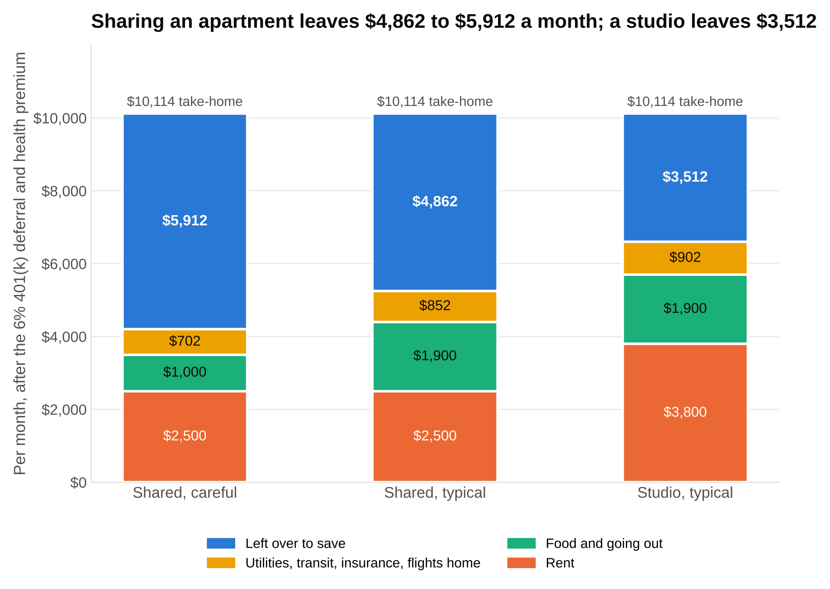
Rent is the only line that moves the savings number by more than a few hundred dollars, and switching from a shared apartment to a studio costs $1,350 a month of it.

[VERIFY: rent and transit inputs as above; the other lines are budgeting assumptions, not sourced figures; take-home from section 5, script-checked]

A first-year analyst in New York who shares an apartment can realistically put away $4,000 to $6,000 a month on top of the 401(k), and choosing a studio over a share cuts that by $1,350 a month. Rent is 24.7 percent of take-home in the shared case and 37.6 percent in the studio case.

Two cautions on reading the table. First, the monthly take-home figure assumes the bonus is spread across the year, and it isn't; for the first twelve months you're living on the base, which after taxes, the 401(k) and the health premium is about $2,950 a paycheck on a $120,000 base, so the first year's savings come in two lumps, not twelve. Second, the typical column is typical for a reason. Most first-years don't save 58 percent, and the ones who save 48 percent are already doing better than almost everyone they graduated with. The point of the table is that the savings rate is a choice about rent and nights out, not about the salary.

9. Take-home rises about $20,000 a year through the analyst years, and the associate jump is smaller after tax than before it
The analyst scale steps up every year, and the bonus range widens with it. Here's a bulge bracket analyst who lands in the middle-to-upper bucket each year, then takes the direct promotion to associate.

Year | Base | Bonus | All-in | Total taxes | Take-home | Effective rate | Take-home step up
First-year analyst | $110,000 | $75,000 | $185,000 | $64,434 | $120,566 | 34.8%
Second-year analyst | $125,000 | $100,000 | $225,000 | $79,727 | $145,273 | 35.4% | $24,708
Third-year analyst | $135,000 | $130,000 | $265,000 | $99,395 | $165,605 | 37.5% | $20,332
First-year associate (direct promote) | $175,000 | $120,000 | $295,000 | $113,614 | $181,386 | 38.5% | $15,781

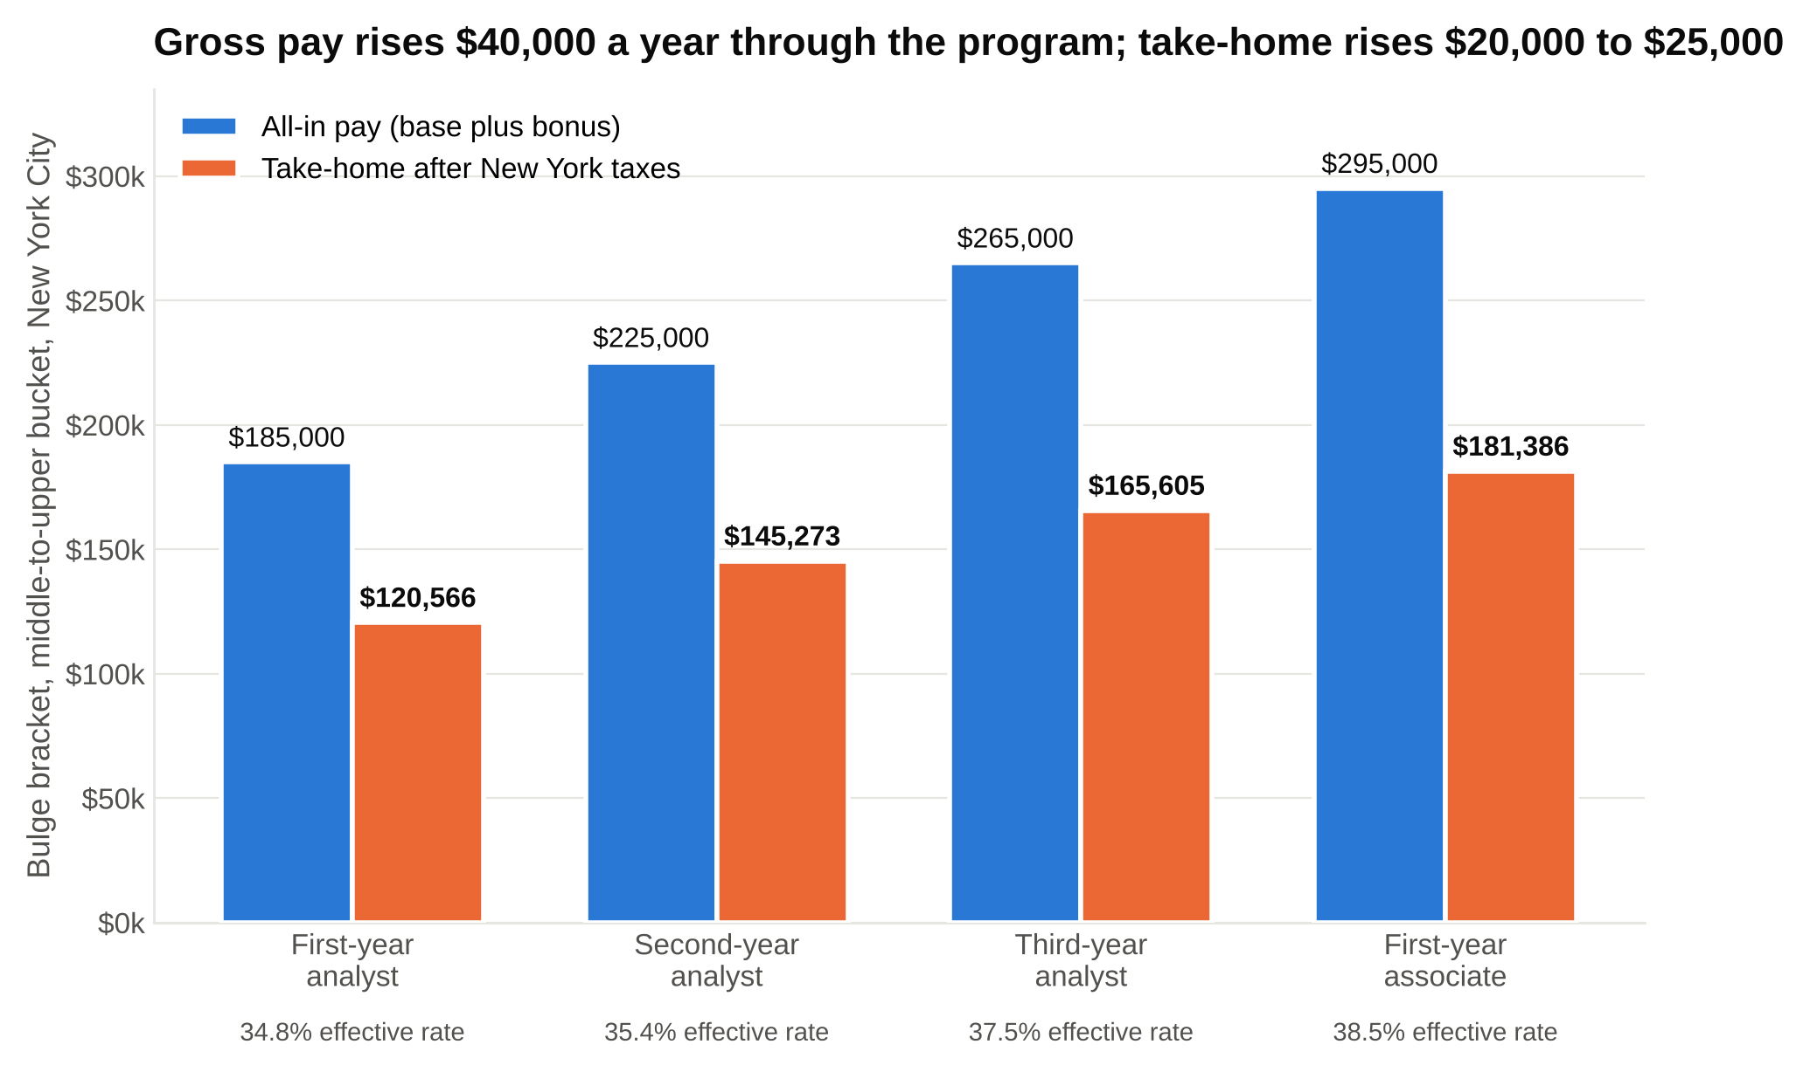
Each $40,000 step in gross pay becomes $24,708, then $20,332, then $15,781 of take-home, because every raise lands in higher brackets and New York phases out its lower rates as you climb.

[VERIFY: second-year reports of $125,000 base with $95,000 to $125,000 bonuses at Bank of America, Citi, JPMorgan, Wells Fargo and UBS and third-year reports of about $135,000 base with $130,000 to $150,000 bonuses at Citi and Wells Fargo, WSO 2026 thread; associate base of $175,000 to $225,000 and first-year associate bonuses of 60 to 70 percent of base per Mergers & Inquisitions, February 2026; several banks add a one-time promotion bonus of about $40,000 that is excluded here; New York City, 2026 rules, no pre-tax deductions, script-checked]

Gross pay rises $40,000 a year through the analyst program, but take-home rises about $20,000 to $25,000 a year, because each raise lands in higher brackets and New York phases out its lower rates as you climb. The effective rate goes from 34.8 percent to 38.5 percent across the four rows. The second-year is already paying the 0.9 percent additional Medicare tax on wages past $200,000 and has crossed into New York's second phase-out above $215,400, which is why the effective rate keeps climbing.

Most banks now promote analysts to associate after two years rather than three, so the third-year row is becoming rare and the associate row arrives a year sooner [VERIFY: two-year analyst programs at most bulge brackets per M&I February 2026]. A direct-promote associate at $175,000 base with a $120,000 bonus keeps $181,386, and a few banks have reported a one-time promotion bonus of about $40,000 on top [VERIFY: $40,000 promotion bonus at Citi and UBS per the WSO 2026 thread].

Now the comparison every sophomore eventually makes. Here are four entry-level seats on the same New York tax engine, with the hours each one is known for.

Job | Base | Bonus | All-in | Take-home | Hours a week | Take-home per hour
Investment banking analyst (bulge bracket, middle bucket) | $110,000 | $75,000 | $185,000 | $120,566 | 85 | $28/hr
McKinsey business analyst | $112,000 | $30,000 | $142,000 | $95,526 | 60 | $32/hr
Private credit analyst (first year, mid) | $140,000 | $75,000 | $215,000 | $139,863 | 65 | $43/hr
Equity research associate (first year, mid) | $120,000 | $40,000 | $160,000 | $105,891 | 60 | $35/hr

[VERIFY: McKinsey BA base of about $110,000 to $112,000 and bonus of about $30,000 per the WSG McKinsey salary post; private credit first-year base of $130,000 to $150,000 and bonus of $50,000 to $100,000 per the WSG private credit salary post; equity research associate all-in of $125,000 to $200,000 per the WSG equity research post, split here into base and bonus as an assumption; hours are typical ranges, not measured, with banking at 80 to 100, consulting and research at 55 to 65, private credit at 60 to 75; 50 working weeks; script-checked]

Banking pays the most dollars of the four entry jobs and the fewest dollars per hour. The first-year banker takes home $25,000 more than the McKinsey analyst and $15,000 more than the research associate, and earns less per hour than either, because a 4,250-hour year is a lot of hours to divide by. Private credit wins both, which is part of why the credit route has gotten crowded; our private credit salary breakdown covers that path and the McKinsey salary guide and equity research explainer cover the other two. The per-hour column isn't an argument against banking. It's the price of the training and the exit options, and it's worth paying with your eyes open.

10. 2027 pay will be set by the bonus pool, not by a raise, and the last raise came from a slide deck
Students ask me whether bases will go up for the 2027 class. The honest answer is probably not, and the reason is in how the last raise happened.

In early 2021, thirteen first-year analysts at Goldman Sachs put together an internal survey and presented it to management as a slide deck. They reported averaging more than 95 hours a week, sleeping about five hours a night, and one of them wrote that the conditions were "beyond the level of 'hard-working.' This is inhumane." The deck leaked in March 2021 and ran on CNN and across the financial press [VERIFY: CNN, March 18, 2021: 13 analysts, more than 95 hours a week, five hours of sleep, the "inhumane" quote]. That spring, every bank was fighting to hire juniors for a record deal year, tech companies were competing hard for the same graduates, and the deck made the whole thing public.

The raises came within months. JPMorgan lifted first-year base from $85,000 to $100,000 in June 2021 [VERIFY: CNN, June 29, 2021]. Goldman went from $85,000 to $110,000 on August 3, 2021, with second-years to $125,000 and first-year associates to $150,000, and Bank of America, Jefferies and William Blair matched the $110,000 [VERIFY: Banking Dive, August 3, 2021; eFinancialCareers, August 2021]. Evercore went to $120,000 plus a $15,000 signing bonus [VERIFY: Business Insider via eFinancialCareers, August 2021]. JPMorgan raised junior pay a second time in January 2022 to catch up [VERIFY: Bloomberg, January 19, 2022, "JPMorgan raises salaries for junior bankers for second time"]. The 2021 raise took first-year base from $85,000 to $110,000 in about a year, a 29 percent jump that started with thirteen analysts and a slide deck, and it has stayed in place ever since.

Base salaries move only when banks are competing for juniors, and in 2026 they aren't: deal fees are up, hiring in tech and consulting is slow, and the 2026 class got the same base as the 2022 class. Goldman's investment banking fees rose 21 percent in 2025, and junior pay rose about 5 percent, which tells you where the pool went [VERIFY: Goldman 2025 8-K exhibit; M&I February 2026]. A 2027 base raise would need a 2021-style combination: a deal boom, competing offers from outside finance, and analysts leaving. Watch for those three things, not for rumors.

What will move the 2027 numbers is the bonus pool, and the pool follows fees. If 2026 and 2027 deal activity holds at 2025 levels, the Summer 2027 and Summer 2028 first-year bonuses should look like the 2026 ones: $45,000 to $100,000 at bulge brackets, higher at the elite boutiques [VERIFY: projection based on the 2026 season; refresh after the Summer 2027 bonus season]. If activity falls, the bottom bucket falls first and furthest, as Deutsche Bank's $20,000 bottom bucket in 2026 shows [VERIFY: WSO 2026 thread].

Two smaller things move the take-home side every year without anyone announcing them. The federal brackets and standard deduction are indexed to inflation each fall, so the 2027 and 2028 tax years will let a little more income through at the lower rates [VERIFY: the IRS publishes the next year's figures each October or November]. The Social Security wage base moves with the national average wage index, from $176,100 in 2025 to $184,500 in 2026, so each year a little more of the bonus is subject to the 6.2 percent [VERIFY: SSA, 2025 and 2026 wage bases]. Neither is big. Both are worth knowing about, so the figures here don't surprise you when they drift.

Say this, don't say that: talking about pay on networking calls and in interviews
Pay questions are allowed. The wrong ones make you sound like you're ranking the bank by the bonus, which is exactly how the bank doesn't want to be ranked. The right ones get you better information anyway.

On a networking call, asking about compensation
Don't say: "What's the bonus like?"
Say: "How are first-year bonuses bucketed at your bank, and does the group's deal flow change the range much?"

The first version gets a number the analyst isn't supposed to share and a note in their head. The second gets you the mechanism from section 3, which is what you actually need.

When an interviewer asks what you know about analyst pay
Don't say: "I think it's around $200,000 all-in, which is one of the reasons I'm interested."
Say: "My understanding is base is on a fixed scale and the bonus depends on ranking and the bank's year, so I'm focused on getting into the group where I'll learn the most."

When the offer arrives and you want to negotiate
Don't say: "Can you match the $120,000 base at [other bank]?"
Say: Nothing about base; it's set for the class. If you have a competing offer, ask whether the signing bonus has any flexibility, and ask HR which bonus calendar the bank uses so you can plan the first year.

When a friend asks whether the money is good
Don't say: "It's $200K."
Say: "It's about $130K after New York taxes, before the 401(k), and most of the bonus shows up once a year."

Students who can say the second version of each of these come across as people who have already done the math, which is the impression you want a bank to have of its future analysts. For what actually determines who gets the seat, our guide to how hard it is to get into investment banking is the place to go next.

The number to carry around
Carry $130,000, not $200,000. That's a top-bucket bulge bracket or middle-bucket elite boutique first-year in New York after taxes, and it drops to about $120,000 for the middle of a bulge bracket class and about $103,000 at the bottom. Decide your rent on the base, decide your savings rate on the bonus after it has cleared, and open the 401(k) on the first paycheck. Then go earn the top bucket, because the $55,000 between the bottom and the top of your class is the only part of an investment banking analyst salary that was ever up to you.

